**LEBANESE AMERICAN UNIVERSITY**

**USAID – HIGHER EDUCATION SCHOLARSHIP PROGRAM**

**HES - Volunteering Program Verification Form**

This form is to be used to document volunteering hours. If a student volunteers for multiple organizations, a separate form must be used for each organization. **This form must be turned in by the 28th of each month, the latest.**

I certify that the scholar Maria Mahmoud Solh completed a total of 3 hours of service at Life Sculptor.

The hours were completed hours as per the below:

Hours # 0 (date) _02/09 - 06/09_ (initials of supervisor) __A.K.___

Hours # 0 (date) _09/09 – 13/09_ (initials of supervisor) __A.K.___

Hours # 0 date) _16/09 – 20/09 (initials of supervisor) __A.K.___

Hours # 3 date) _23/09 – 27/09 (initials of supervisor) __A.K.___

Brief description of the activities the scholar performed or participated in:

I did a research about Yaemil including four topics:   
Structure of an effective MUN speech  
Public speaking techniques for MUN  
Writing tips for a constructive MUN speech  
Advanced speechwriting techniques

Written feedback about the scholar’s performance:

Maria demonstrated strong research and communication skills by covering four key topics related to MUN: structuring an effective MUN speech, public speaking techniques, writing tips for constructive speeches, and advanced speechwriting techniques. Her ability to organize and present information clearly highlights her expertise in public speaking and speechwriting.

Please rate the overall performance of the scholar at your organization:

|  |  |  |  |
| --- | --- | --- | --- |
|  | Mastery (5) | Proficient (3) | Emerging (1) |
| **Problem solver** | X |  |  |
| **Engaged & Committed** | X |  |  |
| **Open-minded & multicultural** | X |  |  |

Signature

& stamp

__________________________

_

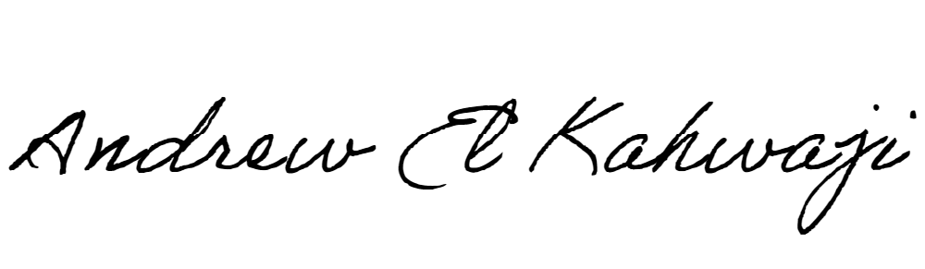

Printed Name _Andrew El Kahwaji_

Date __25/09/2024___

Email __andrew.lifesculptor.coo@gmail.com __

Phone __+961 71 914 378__

**LEBANESE AMERICAN UNIVERSITY**

**USAID – HIGHER EDUCATION SCHOLARSHIP PROGRAM**

